Viewing Student Report Cards and Progress Reports for Parents and Students

Log in to your Family Portal account or Student account. Locate the Published Reports
widget on the page.

Things to know:
- Reports will only be available for a limited time.
- An email is generated to portal account holders to notify that a new report has been added. There is no link on the email. You must navigate to the Family Portal.
- Downloads are handled differently on every computer. Be sure that you know where the downloaded files are located on your computer.



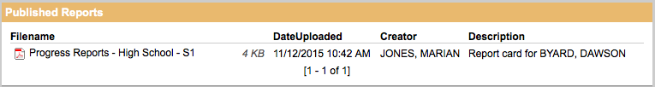
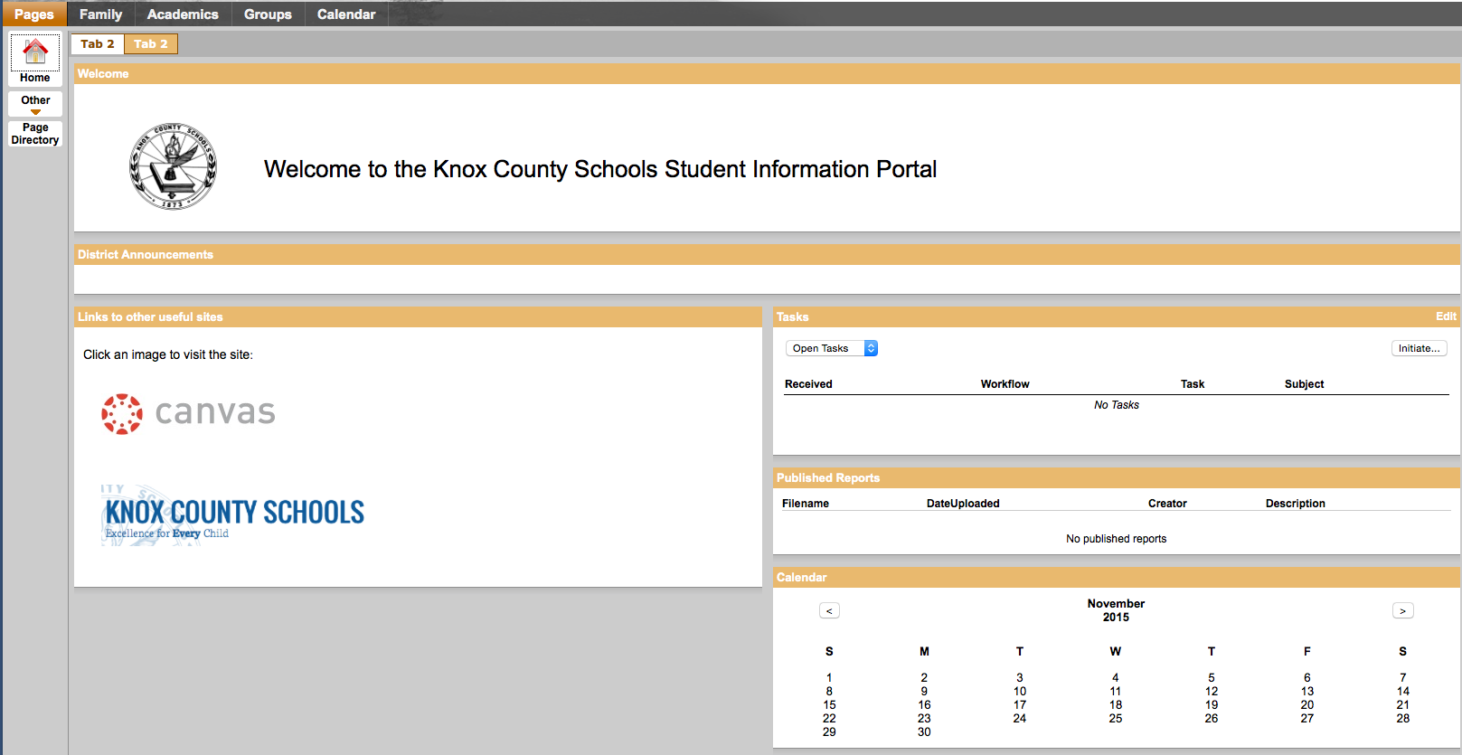

Click on the file to download it to your computer.


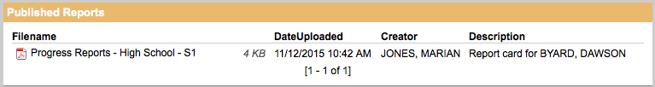

Viewing Student Report Cards and Progress Reports for Parents and Students: Mobile View

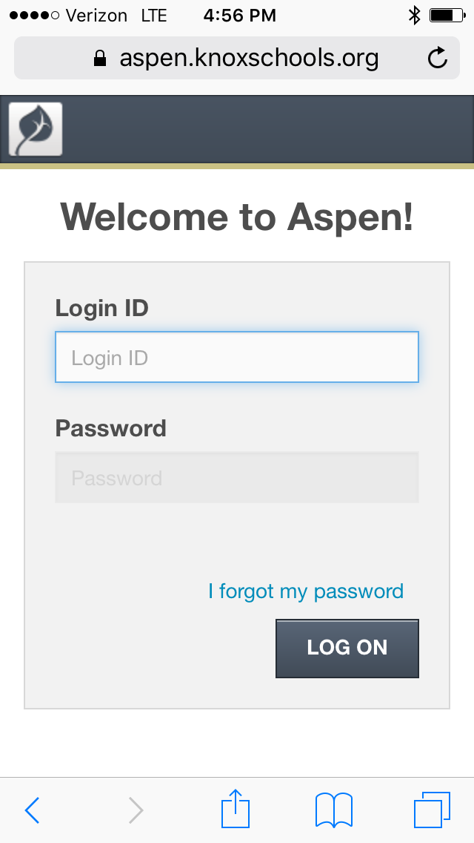
Log in to your Family Portal account or Student account.

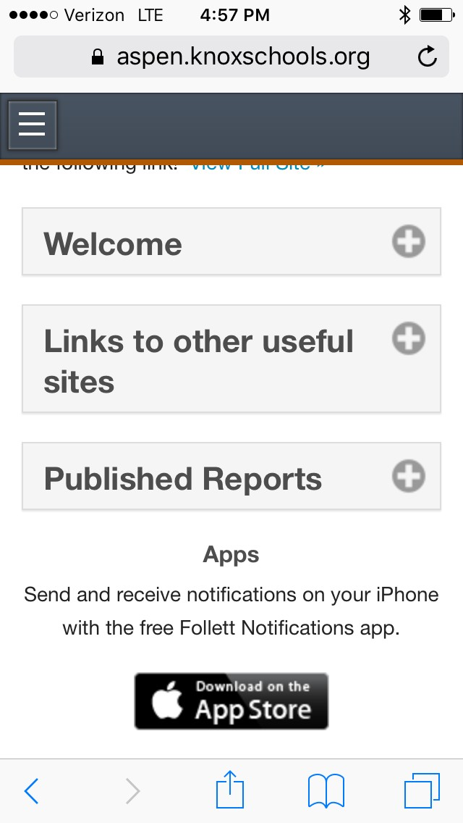
Scroll down to find the Published Reports. Click on the plus sign on the right to see available reports.

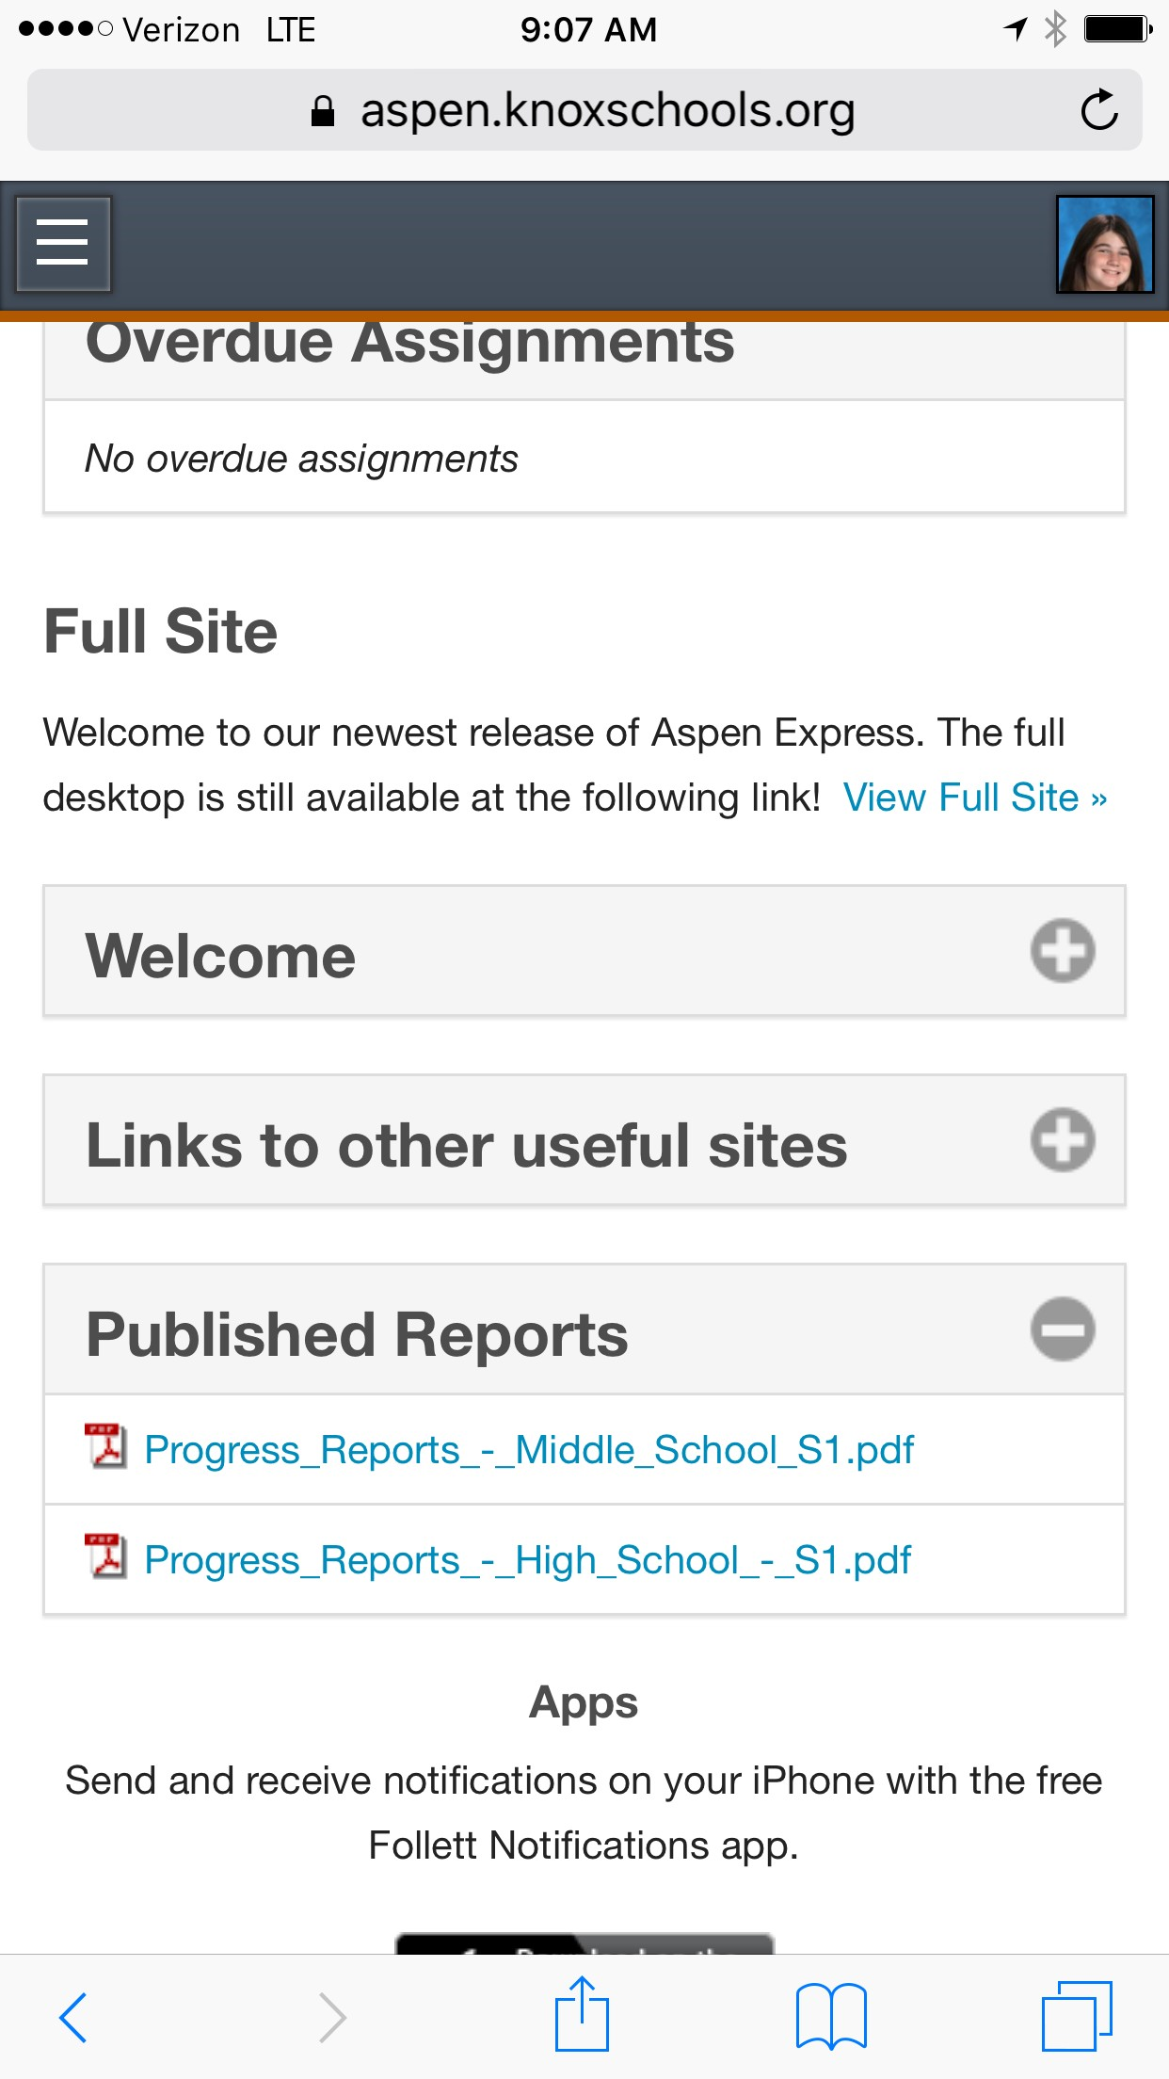
Click on the report that you want to view. It will open as a PDF.

